## Assignments to be done in this session

Accept input from user and display results on console. Make use of loops, switch case wherever required.

1. Create a structure Book which contains the following members:

bookId, title, price, bookType

Type of the book should an enumerated data type with values as Magazine, Novel, ReferenceBook, Miscellaneous. Write a console based application to do the following tasks.

* 1. Accept the details of the book
  2. Display the details of the book. The type of book should be displayed as a string e.g.:

Magazine

Note: Use methods for accepting and displaying details.

1. Write a Simple console Application Calculator with the help of Visual Studio .NET IDE which will perform following operations on two numbers:
   1. Addition.
   2. Subtraction.
   3. Multiplication.
   4. Division

using System;

using System.Collections.Generic;

using System.Linq;

using System.Text;

using System.Threading.Tasks;

namespace ConsoleApp1

{

class Program

{

static void Main(string[] args)

{

//This is a instructions

/*

*

*/

int a, b, c, lar;

Console.WriteLine("Enter the three numbers");

a = Convert.ToInt32(Console.ReadLine());

b = Convert.ToInt32(Console.ReadLine());

c = Convert.ToInt32(Console.ReadLine());

if (a > b)

{

if (a > c)

{

lar = a;

}

else

{

lar = c;

}

}

else

{

if (b > c)

{

lar = b;

}

else

{

lar = c;

}

}

Console.WriteLine("The largest no is " + lar);

Console.ReadLine();

}

}

}

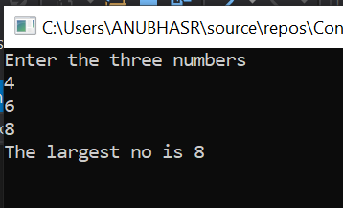

1. Accept average marks of five students. Display the highest marks obtained.

using System;

namespace Task_1_q_2

{

class Program

{

static void Main(string[] args)

{

//2.Accept average marks of five students. Display the highest marks obtained.

int a, b, c, d, e, hig;

Console.WriteLine("Enter Average marks of 5 students");

a = Convert.ToInt32(Console.ReadLine());

b = Convert.ToInt32(Console.ReadLine());

c = Convert.ToInt32(Console.ReadLine());

d = Convert.ToInt32(Console.ReadLine());

e = Convert.ToInt32(Console.ReadLine());

if (a > b && a > c && a > d && a > e)

{

hig = a;

Console.WriteLine("Highest is a: "+hig);

}

else if(b > a && b > c && b > d && b > e)

{

hig = b;

Console.WriteLine("Highest is b: " + hig);

}

else if (c > a && c > b && c > d && c > e)

{

hig = c;

Console.WriteLine("Highest is c: " + hig);

}

else if (d > a && d > b && d > c && d > e)

{

hig = d;

Console.WriteLine("Highest is d: " + hig);

}

else if (e > a && e > b && e > c && e > d)

{

hig = e;

Console.WriteLine("Highest is e: " + hig);

}

//Console.WriteLine("The highest number is :"+hig);

Console.ReadLine();

}

}

}

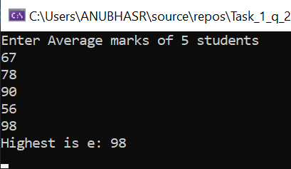

1. Write a static method to accept param array of integers. The method should find the sum of all the integers passed and display the result. Write a client program to call the method.

using System;

namespace Task1_q_3

{

class Program

{

public static int sum(params int[] list)

{

int sum1 = 0;

for (int i = 0; i < list.Length; i++)

{

sum1 = sum1 + list[i];

}

return sum1;

//Console.WriteLine();

}

static void Main(string[] args)

{

int total;

//Can also give input this way

//UseParams(1, 2, 3, 4);

// Or give input this way

int[] inputArray = { 5, 6, 7, 8, 9 };

total = sum(inputArray);

Console.WriteLine("The sum is:" + total);

Console.ReadLine();

}

}

}

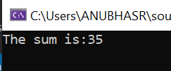

1. Write a method to swap two integers. The client code should call the method and print the swapped value.

using System;

namespace Task_1_q_4

{

class Program

{

public static void swap(int a,int b)

{

int temp;

temp = a;

a = b;

b = temp;

Console.WriteLine($"The swapped value is a={a} b={b}");

}

static void Main(string[] args)

{

int x, y;

x = Convert.ToInt32(Console.ReadLine());

y = Convert.ToInt32(Console.ReadLine());

swap(x, y);

}

}

}

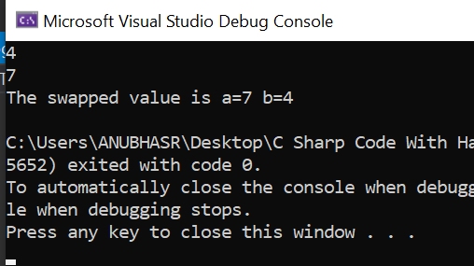

1. Write a single method that calculates the area and circumference of the circle. The area and circumference should be displayed through the client code

using System;

namespace Task_1_q_5

{

class Program

{

public static double areaCircumference(double r,ref double area,ref double circumference)

{

//double area,circumference;

area = 3.14 * r * r;

circumference = 2 * 3.14 * r;

//double[] array = new double[2];

//array[0] = 3.14 * r * r;

//array[1] = 2 * 3.14 * r;

//return array;

}

static void Main(string[] args)

{

double area=0, circumference=0;

//double r = Convert.ToDouble(Console.ReadLine());

areaCircumference(r, ref area, ref circumference);

//int[] array = areaCircumference(r);

Console.WriteLine($"Area = {area}, circumference = {circumference}");

//Console.WriteLine("Area:"+array[0]);

Console.ReadLine();

}

}

}

